SQL NOTES (1)
Introduction to Databases, DBMS, and SQL Basics
Is pehle chapter mein video ke shuruat mein foundational concepts ko revise kiya gaya hai taaki SQL shuru karne se pehle base clear ho jaye.
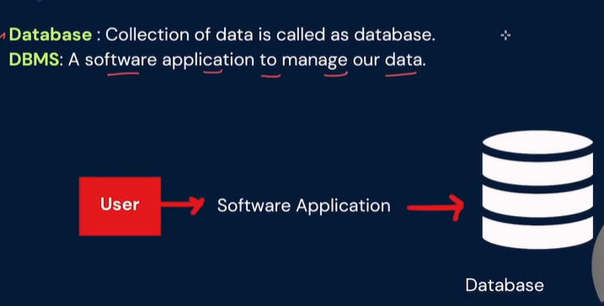
1. Database aur DBMS ka basic farq:
- Database: Ek aisi jagah jahan data systematic tarike se store hota hai (jaise ek bada digital register).
- DBMS (Database Management System): Ek software jo humein database ke sath baat karne (data dalne, nikalne, ya badalne) ki permission deta hai.

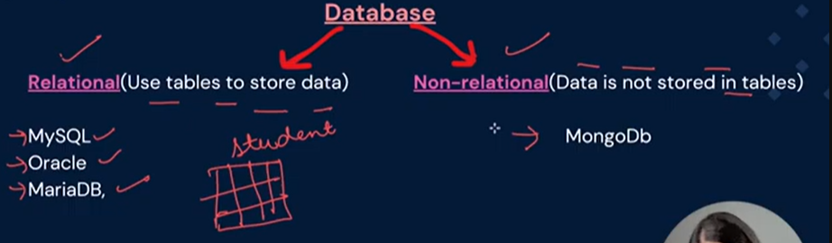
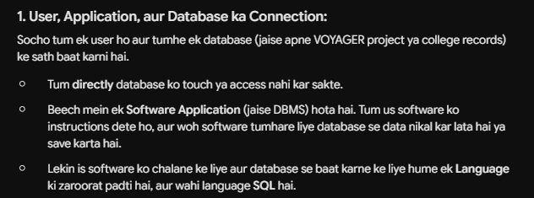
2. SQL vs. MySQL (Sabse bada confusion):
- SQL (Structured Query Language): Yeh ek Language hai (jaise Python ya Java ek language hai). Iska kaam sirf instructions dena hai ki database ke sath kya karna hai.
- MySQL: Yeh ek Software (RDBMS) hai jo is SQL language ko samajhta hai aur backend mein data ko tables ki form mein save karta hai. (Jaise PostgreSQL, Oracle, aur SQL Server bhi dusre RDBMS hain).
3. Server aur Workbench (MySQL ka setup):
- MySQL Server: Yeh background mein chalne wala engine hai jahan actual data save hota hai.
- MySQL Workbench: Yeh ek Visual Interface (UI) hai jahan hum baith kar apni SQL queries likhte hain aur run karte hain.

